**Project on an E-Voting Management System**

This is a simple electronic voting system developed using JSF a MVC based framework as the front-end integration with HIBERNATE and MYSQL as the back-end. It is developed to eliminate the conventional paper ballot- system. This is my first project in JSF/PRIME FACES and HIBERNATE.

**Features:**

1. It is Secure.
2. It is fast and confident.
3. Results are accurate.
4. Reduce crowd at polling unit.
5. Instant results are release immediately after each vote.

**HOW TO GIVE VOTE:**

At first Election commission will entry voter id and he/she will give an ID number to the voter. Then voter can give vote with that ID. A voter can give only one vote.

**RESULT:**

After giving vote EC (Election Commission) will declare the result. The result will be calculated automatically by the System.

**How e-voting management System project works?**

**Home Page:**

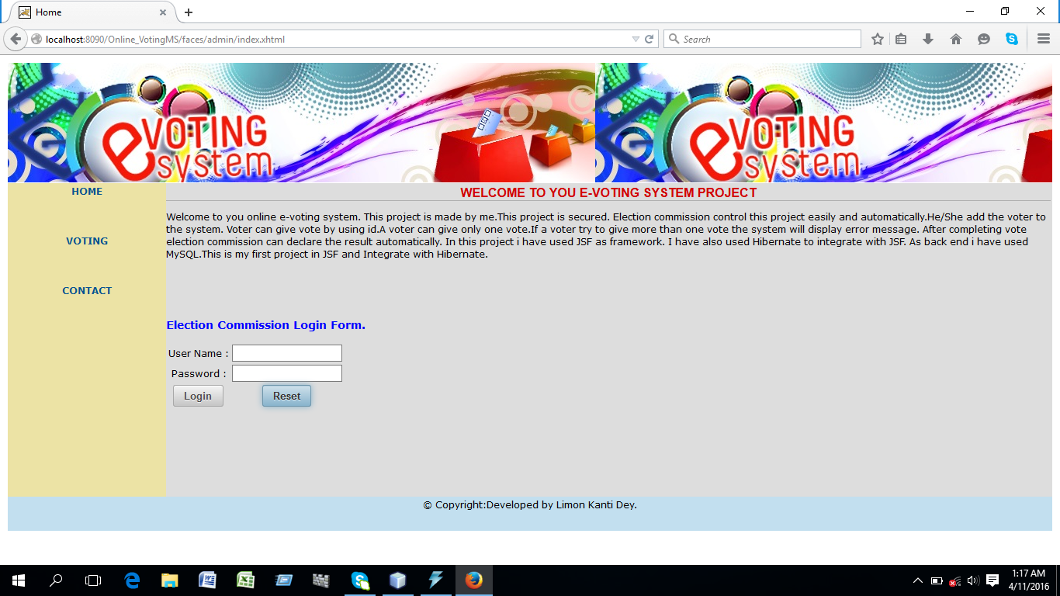

**Steps:**

**1.For election commission**

**1.1 on filling incorrect information like login name and login password it works as follows:**

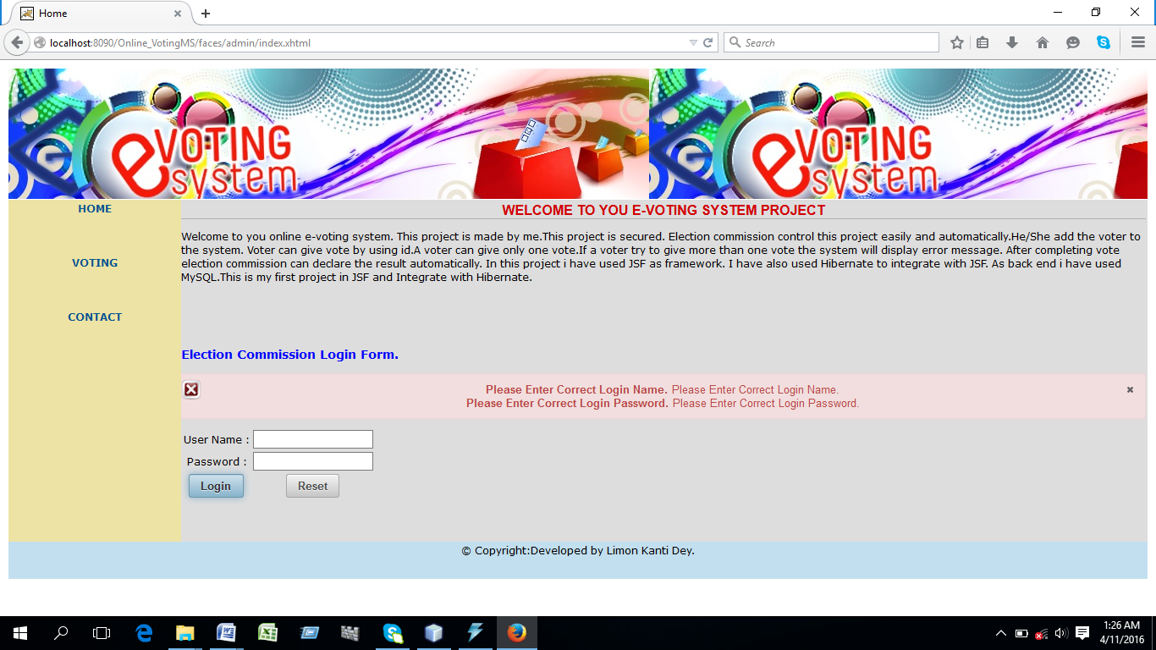

**1.2 on filling correct information election commission can enter his/her profile as follows:**

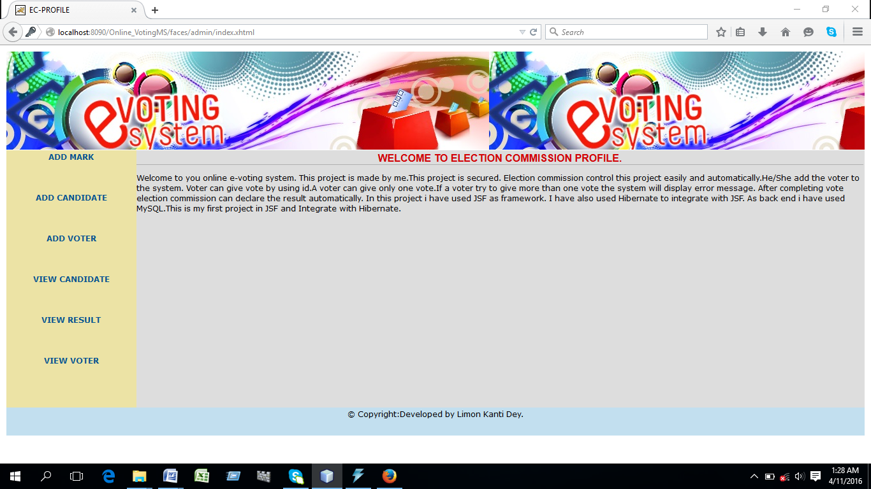

**1.3 Election commission(E.C) can add candidates mark as follows**

**1.3.a. For blank information it works as follows**

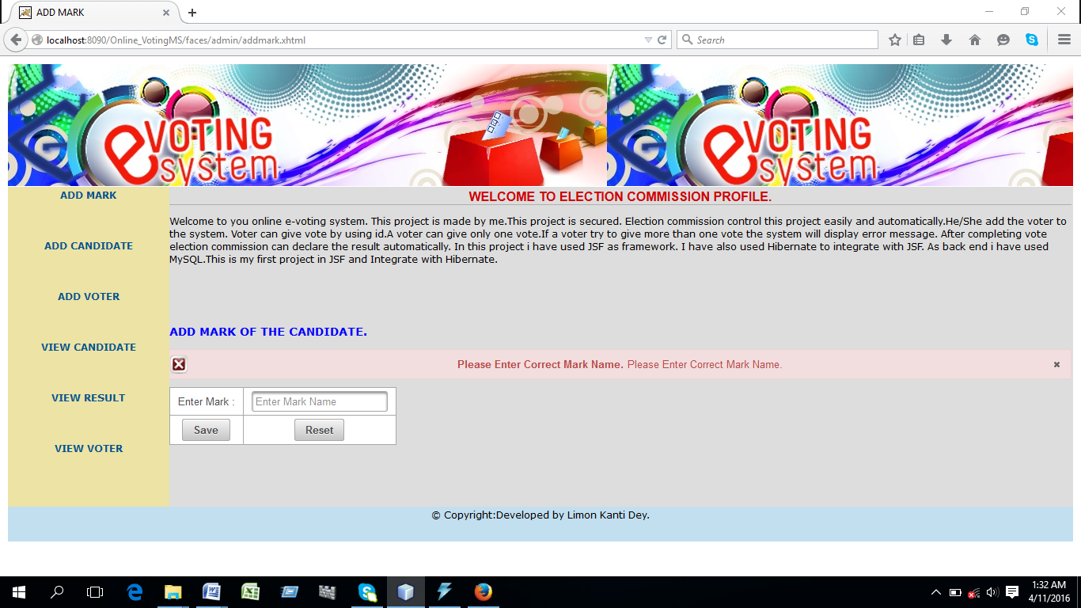

**1.3.a.1.After providing correct information :**

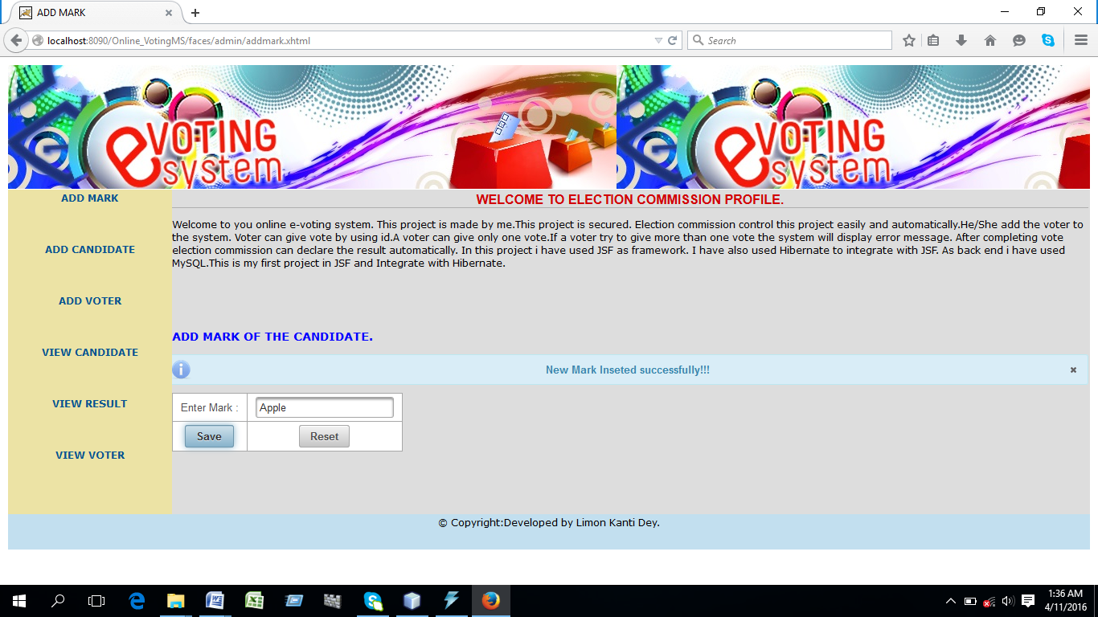

**1.4.EC can add candidate as follows:**

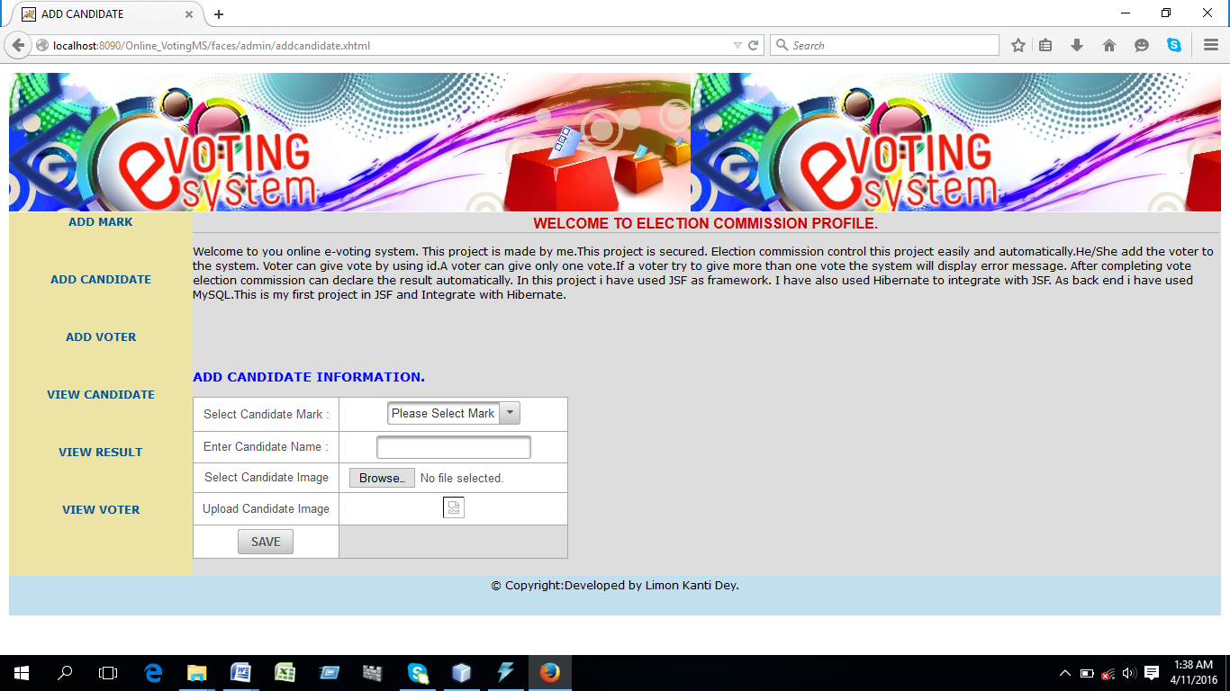

**1.5 EC can add voter as follows**

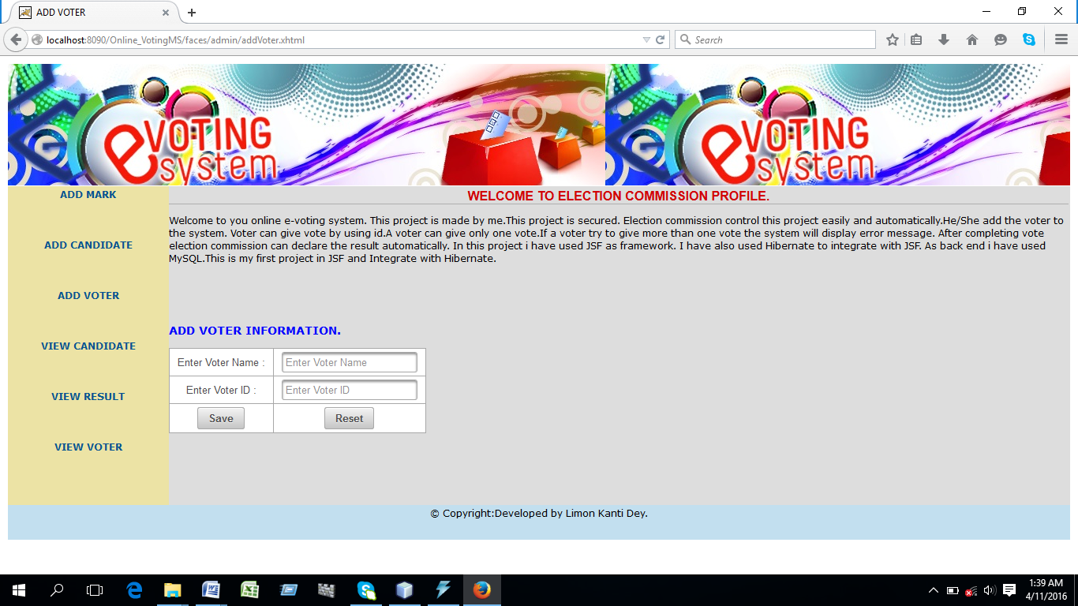

**1.6 EC can see candidates as follows:**

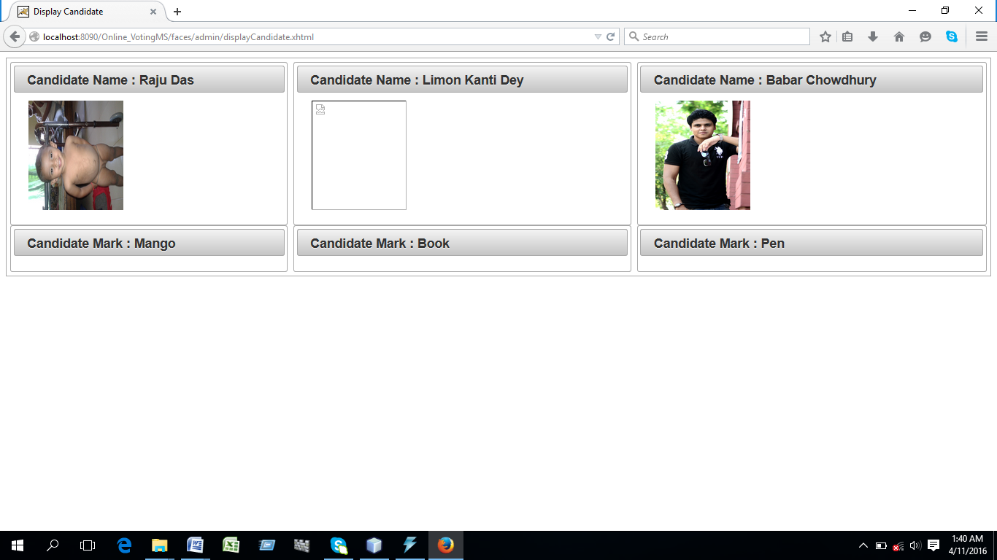

**1.7. EC can get total voter’s information as follows**

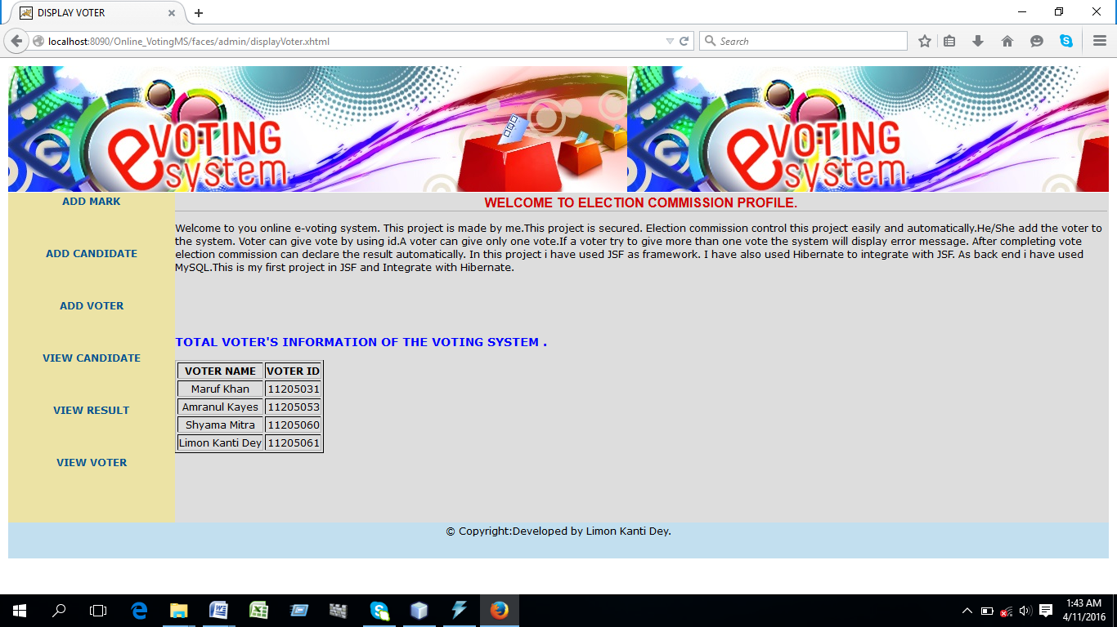

**1.8.EC can get result of the voting system as follows**

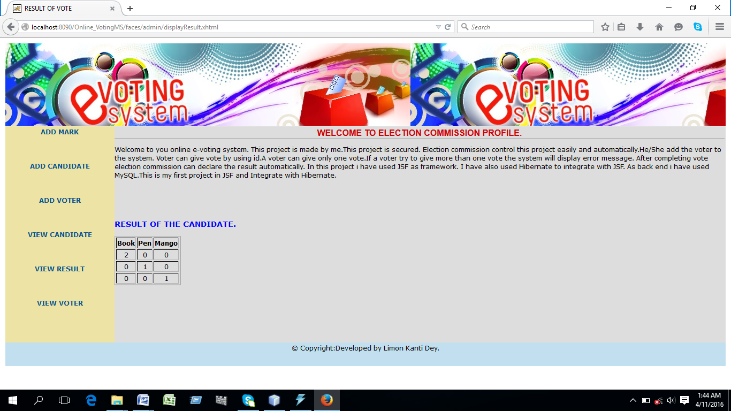

**2.For voter’s:**

**2.1.By providing correct information voter can access profile page for giving vote as follows:**

**Voter profile page:**

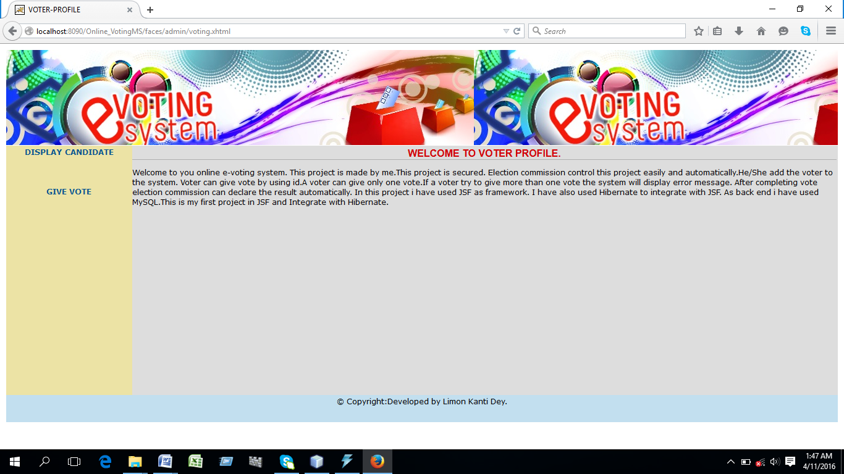

**2.2 voter can see candidate’s before giving vote.**

**2.3.Voter can give vote as follows:**

**After giving vote**

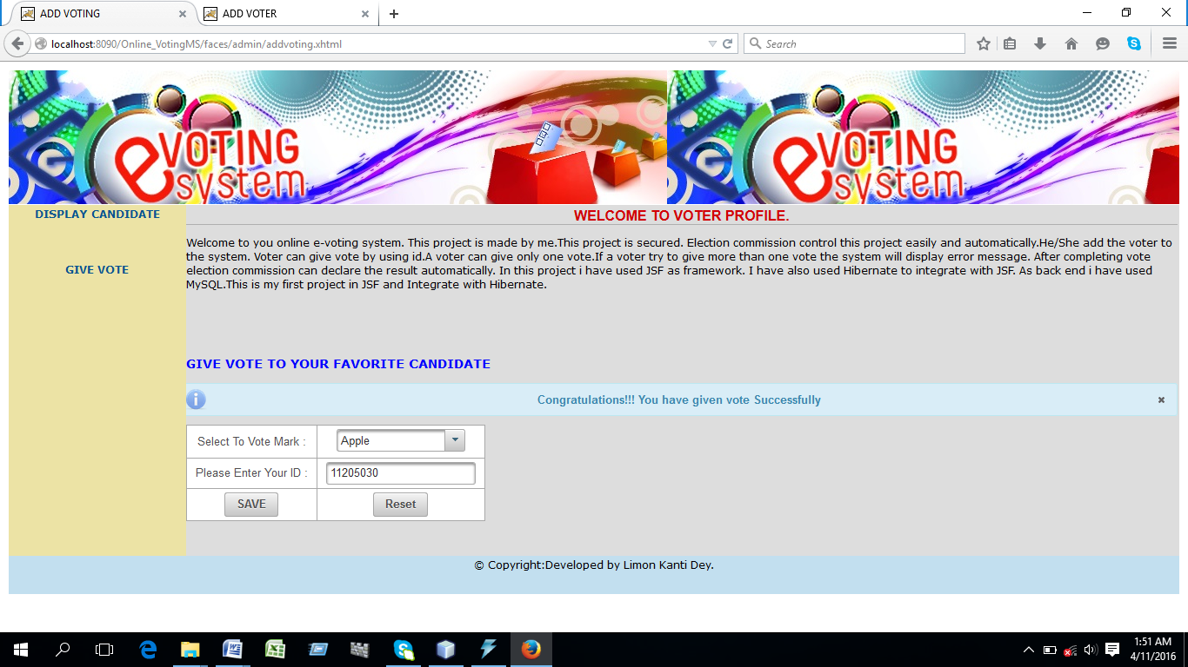

**After giving one vote if he/she tries to give fake vote again it give information as follows**

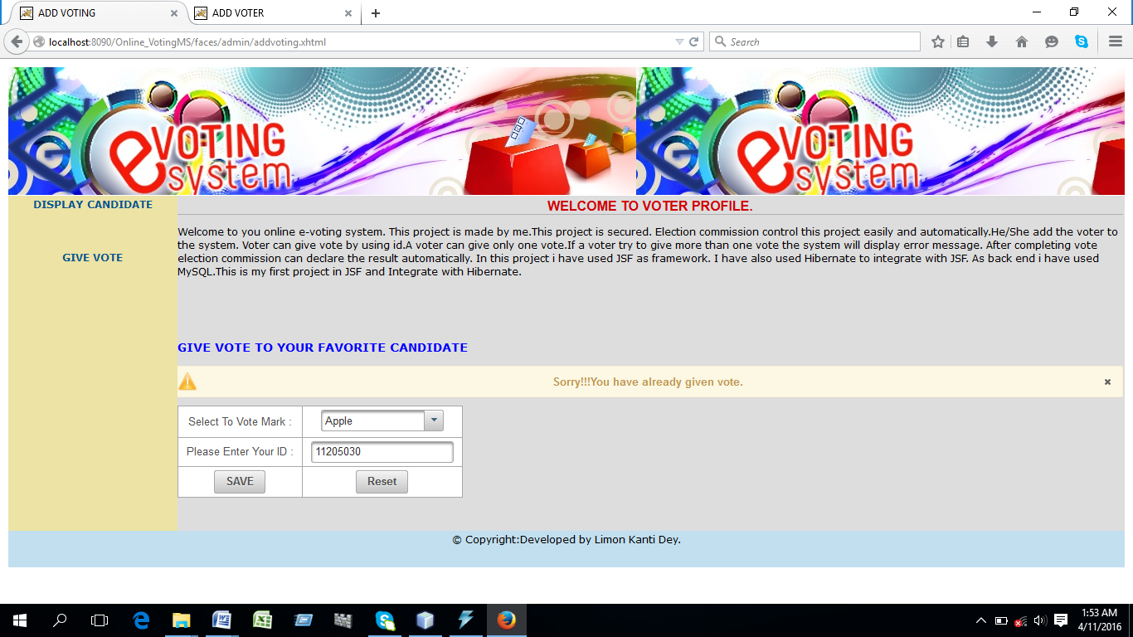

**Best of Luck**